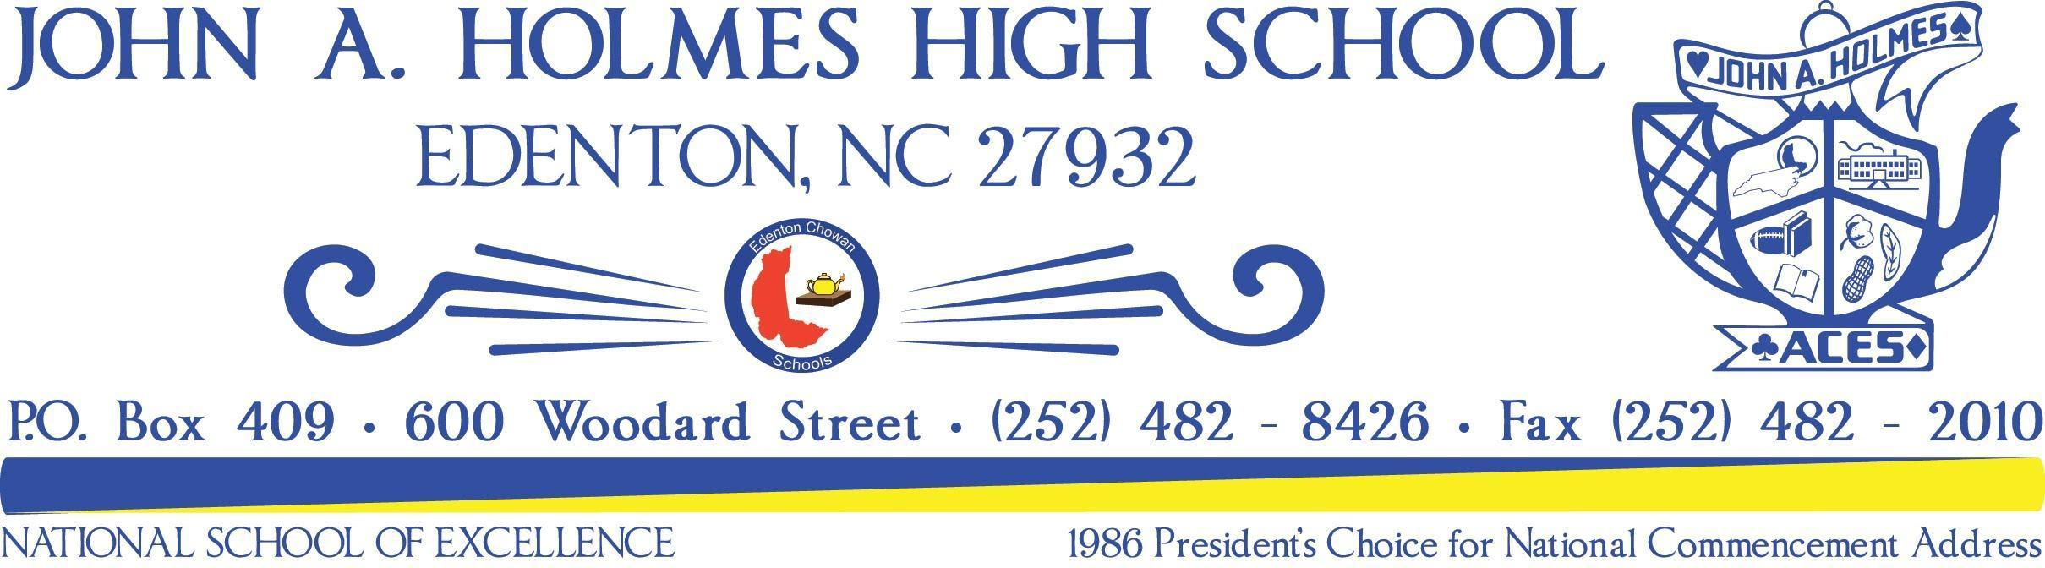
School Improvement Plan
2019-2021
Mission Statement: The mission of John A. Holmes High School is to create academically engaging and challenging learning opportunities to promote the development of successful, responsible, respectful citizens and lifelong learners.
Vision Statement: John A. Holmes provides a safe learning environment that promotes the development of successful, responsible, respectful citizens and lifelong learners

Goal 1: Eliminate Opportunity Gaps
- JAH implementation of MTSS with fidelity in order to reduce the number of lost instructional hours due to inappropriate behavior
  - RTI referral/meeting
  - Office Hours
  - In-Team Teachers utilized
  - Social Worker
  - Training on 3 Tiers of MTSS & modifications
  - Use of grade level teachers for student support
  - Detention
Goal 2: Improve School and District Performance
- Increase student proficiency on Biology, English II, Math I, and Math III
  - Benchmarks aligned to standards
  - Office Hours
  - Vertical Alignment
  - Data collection and analysis during PLTs
  - Math I Check-ins
  - Rigorous test writing strategies
Goal 3: Increase Educator Preparedness
- *Increase the percentage of teachers who meet or exceed growth as measured by EVAAS by 5% annually
  - Test writing strategies
  - PLT meetings
  - Mentor/Mentee support
  - New teacher support through NC State
  - Visit to other schools, classroom
- **Increase the percentage of engaged students in the virtual academic setting.
  - PLT meetings
  - Professional Development Attendance
  - Visits to classrooms
  - Class meetings for remote students
  - Office Hours and 1:1 Google Meets
  - Parent Trainings to support student learning
  - Time management training for students and staff

