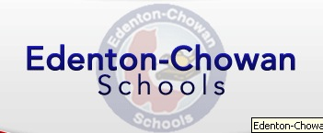

Please join us as we host the
North Carolina State Superintendent of Public Instruction,
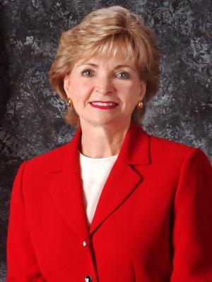
Dr. June St. Clair Atkinson

We will collaborate on the topic
“Pre-K – 5 Literacy Transformation:
Beginning with the End in Mind!”

Wednesday, May 21, 2014
White Oak Elementary School Cafeteria
3:00 p.m. – 3:30 p.m. – Reception

3:30 p.m. – 4:00 p.m. -School & Community Forum
Greetings – Mr. John Guard, Board Chair
“Transforming Literacy”- Michelle White & Jamie Bowers
Comments: Dr. Atkinson
Closing Comments – Dr. Smith

June St. Clair Atkinson was elected as the North Carolina State Superintendent of Public Instruction in November 2004, re-elected in 2008, and re-elected for a third term in 2012. Dr. Atkinson is North Carolina's first woman elected to this position. She heads the NC Department of Public Instruction, an agency which she served for nearly 34 years as a chief consultant and director in the areas of business education, career and technical education, and instructional services.

Please help us welcome Dr. Atkinson to Edenton-Chowan Schools!
Please contact Linda White, Director of Elementary Education, at lwhite@ecps.k12.nc.us or 482-4436 to RSVP or for more information.

